LOGBOOK 13

Team 1 : Student Enegy – Hand Ball

Artist :

* Membantu programmer melengkapi art yang kurang

Programmer :

Testing di HP

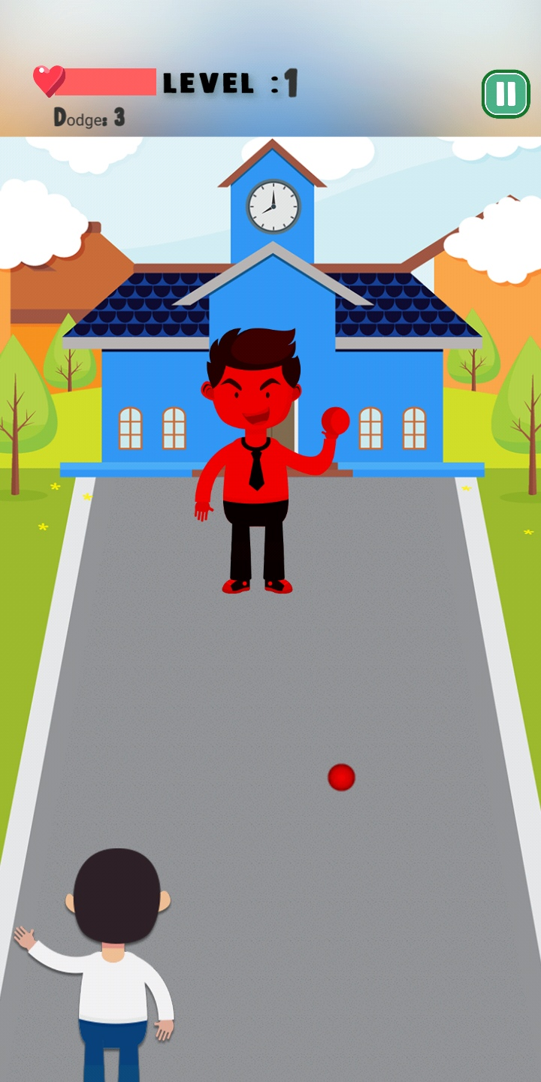

* Game Design Document Update
* Mechanic Update
* Main Menu
* Main Menu Development
* Fix Mechanic.